1. PDS

Generated PDF file of PDS



**DILG-CAR Employee**



**DILG-CAR HRIS Web Application**

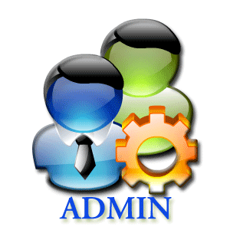

**DILG-CAR HR Admin**

Log in  
Filling out of PDS

View/Update/Edit PDS for Corrections

Validation of Employee PDS

Submit to HR

Store PDS

Retrieve PDS



**Database**

2. Leave Application

Log in  
Filling out of Leave Application

Update and



**DILG-CAR Employee**



**DILG-CAR HRIS Web Application**



**DILG-CAR HR Admin**

Marks “Accepted Leave” if the Regional Director Approves the Leave Application



**Database**

Store Leave Application

Retrieve PDS

Generated PDF file of Leave Application



**DILG-CAR Regional Director**



**DILG-CAR Officer**

Submit the printed Leave Application to HR

Submit to DILG-CAR Director

Submit to DILG-CAR Officer

3. Processing of Employee’s Leave Credits